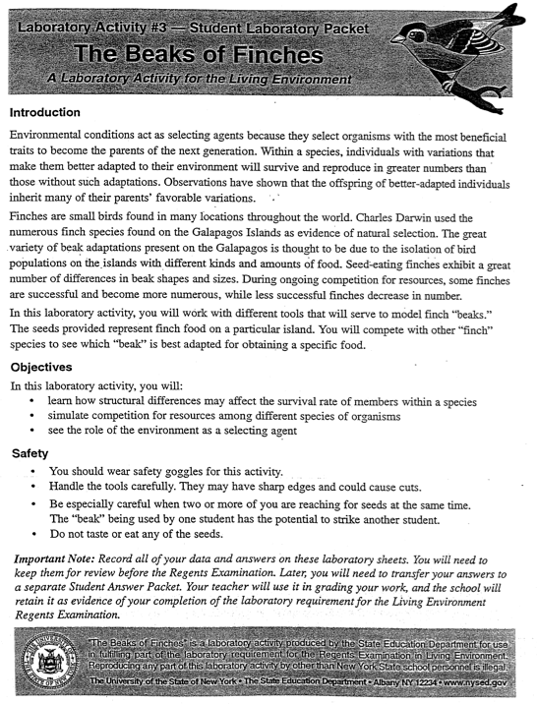

**Part 1: Observations and Predictions**

1. Examine the different tools (Beaks) and seeds provided. Predict which beak will be the **most** successful at picking up **small seeds. Why?**
2. Predict which beak will be the **least** successful at picking up **small seeds. Why?**
3. You will be assigned a tool to be your pretend “beak.” Describe the characteristics of the beak. Do you think it will pick up small or large seeds better**? Why?**
4. Below: Draw a diagram of your assigned “beak”

Name: Seat: Date:

Living Environment : Beaks of Finches Lab Period:

**Part 2: Experimentation**

**Round 2: Feeding without competition**

In this first round you will pretend to be birds feeding on an island without competition.

**Procedure:**

1. Teacher will give you a signal to start
2. YOU AND YOUR PARTNER: With your assigned “beak,” pick up ONE seed from dish one that represents your island ecosystem
3. Place seed into dish 2 that represents your stomach
4. Record data on the table below
5. Repeat steps 1-4 for trial 2.
6. Calculate the average of all trials for round one feeding
7. If your average is greater than 13 you stay on Small Seed Island
8. If your average is less than 13 you migrate to the Large Seed Island

**Round 1: Feeding with No Competition**

|  |  |  |
| --- | --- | --- |
|  |  | Seeds Collected |
| Partner #1 | Trial 1 |  |
| Trial 2 |  |
| Partner #2 | Trial 1 |  |
| Trial 2 |  |
|  | Average: |  |

**Round 2: Competition**

In this round you will pretend to be finches competing with other finches, with different adaptations, for food

**Procedure:**

1. Check the box for Small Seed Island or Large Seed Island
2. Teacher will give you a signal to start
3. YOU AND YOUR PARTNER: With your assigned “beak,” pick up ONE seed from dish one that represents your island ecosystem
4. Place seed into dish 2 that represents your stomach
5. Record data on the table below
6. Repeat steps 2-5 for trial 2.
7. Calculate the average of all trials for round one feeding
8. If your team had an average of 13 or higher, you survived! Go on to round 3
9. If you team had an average of 13 or lower, you were competed! You have been excluded from the island. Do not go onto round 3

**Round 2: Competition**

**Small Seed Island Large Seed Island**

|  |  |  |
| --- | --- | --- |
|  |  | Seeds Collected |
| Partner #1 | Trial 1 |  |
| Trial 2 |  |
| Partner #2 | Trial 1 |  |
| Trial 2 |  |
|  | Average: |  |

**Round 3: Increased Competition**

Congratulations you have survived to Round 3! But the competition has increase. You will be competing with all other finches on your island!

**Procedure:**

1. Check the box for Small Seed Island or Large Seed Island
2. Teacher will give you a signal to start
3. YOU AND YOUR PARTNER: With your assigned “beak,” pick up ONE seed from dish one that represents your island ecosystem
4. Place seed into dish 2 that represents your stomach
5. Record data on the table below
6. Repeat steps 2-5 for trial 2.
7. Calculate the average of all trials for round one feeding
8. If your team had an average of 13 or higher, you survived!
9. If you team had an average of 13 or lower, you were competed! You have been excluded from the island.

**Round 3: Increased Competition**

**Small Seed Island Large Seed Island**

|  |  |  |
| --- | --- | --- |
|  |  | Seeds Collected |
| Partner #1 | Trial 1 |  |
| Trial 2 |  |
| Partner #2 | Trial 1 |  |
| Trial 2 |  |
|  | Average: |  |

**Part 3: Class Data**

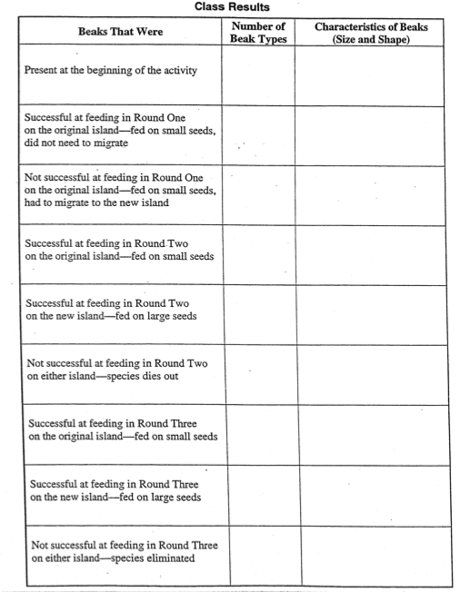

Name: Seat: Date:

Living Environment : Beaks of Finches Lab Period:

**Part 4: Analysis Questions: Lab group**

1. What characteristics of your beak interfered with feeding success on Small Seed Island?
2. Name 3 traits, OTHER THAN THE BEAK, that would help a finch compete for seeds (ex; fast flyer).
3. Random mutations and new gene combinations from sexual reproduction may create beak variations. Describe at least **3 beak variations** that could randomly appear and further your species chance of surviving
4. Why did some beaks survive on the Large Seed Island when they couldn’t survive on Small Seed Island?

**Part 5: Analysis Questions: Class Data**

1. Did those who stayed on Small Seed Island survive equally well in Round 2? Why?
2. Why were there fewer survivors at the end of Round 3?
3. What types of “beaks” were successful at the end of Round 3 on Large Seed Island? Were those “beaks” different from those at the end of Round 3 on Small Seed Island? Why?
4. How did this lab show competition? How did this lab show adaptation?

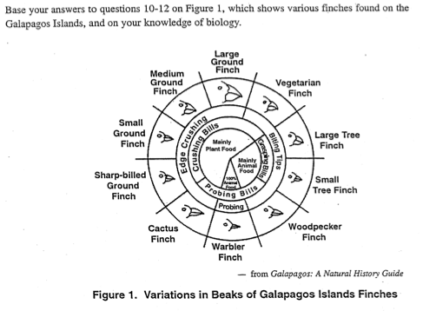

1. Predict which species of finch would most likely survive if the weather on the Galapagos Islands gradually changed, and the seeds available to the finches became larger with heavier coverings. Why?
2. One island is populated by 2 species**: Ground Finches** and **Small Tree Finches**
   1. What 2 types of food would you expect to be on this island? Why?
   2. Would you expect the 2 species to compete for food? Why?
   3. How might the 2 native finches populations be affected is **Sharp-billed Ground Finches** migrated to the island? Why?
3. A. Explain how an island could support large populations of both **Large Ground Finches** and **Small Ground Finches**.

12) B. How could you use materials provided in this lab to test your explanation to 12 A?