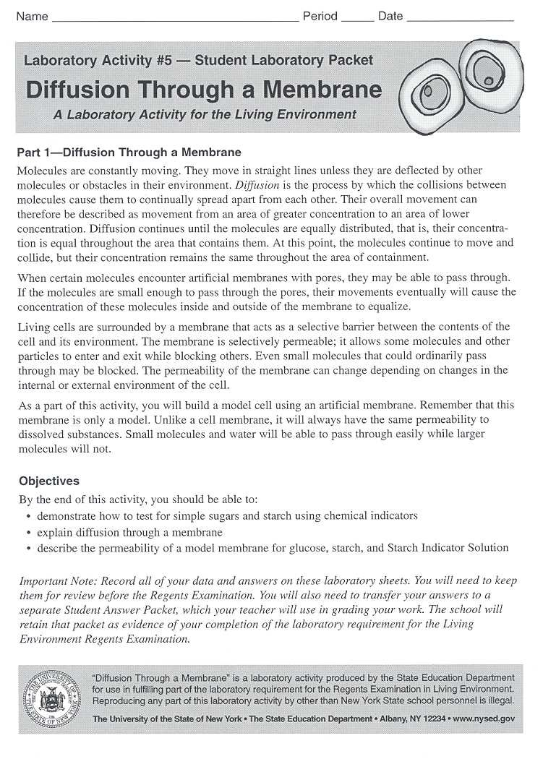

Part 1: Making a Cell
KEY: Regular text- Ms. Clark does
Bold text- You do
Procedure:
1) Ms. Clark will make a model cell using Dialysis Tubing. The tubing acts just like a cell membrane because it is selectively permeable
2) Ms. Clark will add GLUCOSE and STARCH into the model cell, and tie the cell closed.
3) The cell will be placed in a beaker of WATER. Ms. Clark will add LUGOL’S IODINE SOLUTION to the water outside of the cell
4) The cell will be set aside for 15 minutes. TURN TO PAGE 3
QUESTION 1: PREDICT what will happen to the substances inside and out of the cell? Your answer should include the word “diffusion”
__________________________________________________________________________________________________________________________________________________________________________________________________________________________________________
QUESTION 2: Fill in the “Initial State” Diagram 1.0 . S= Starch, G=Glucose, L= Lugol’s Iondine, W= Water. COLOR the image.
Diagram 1.0
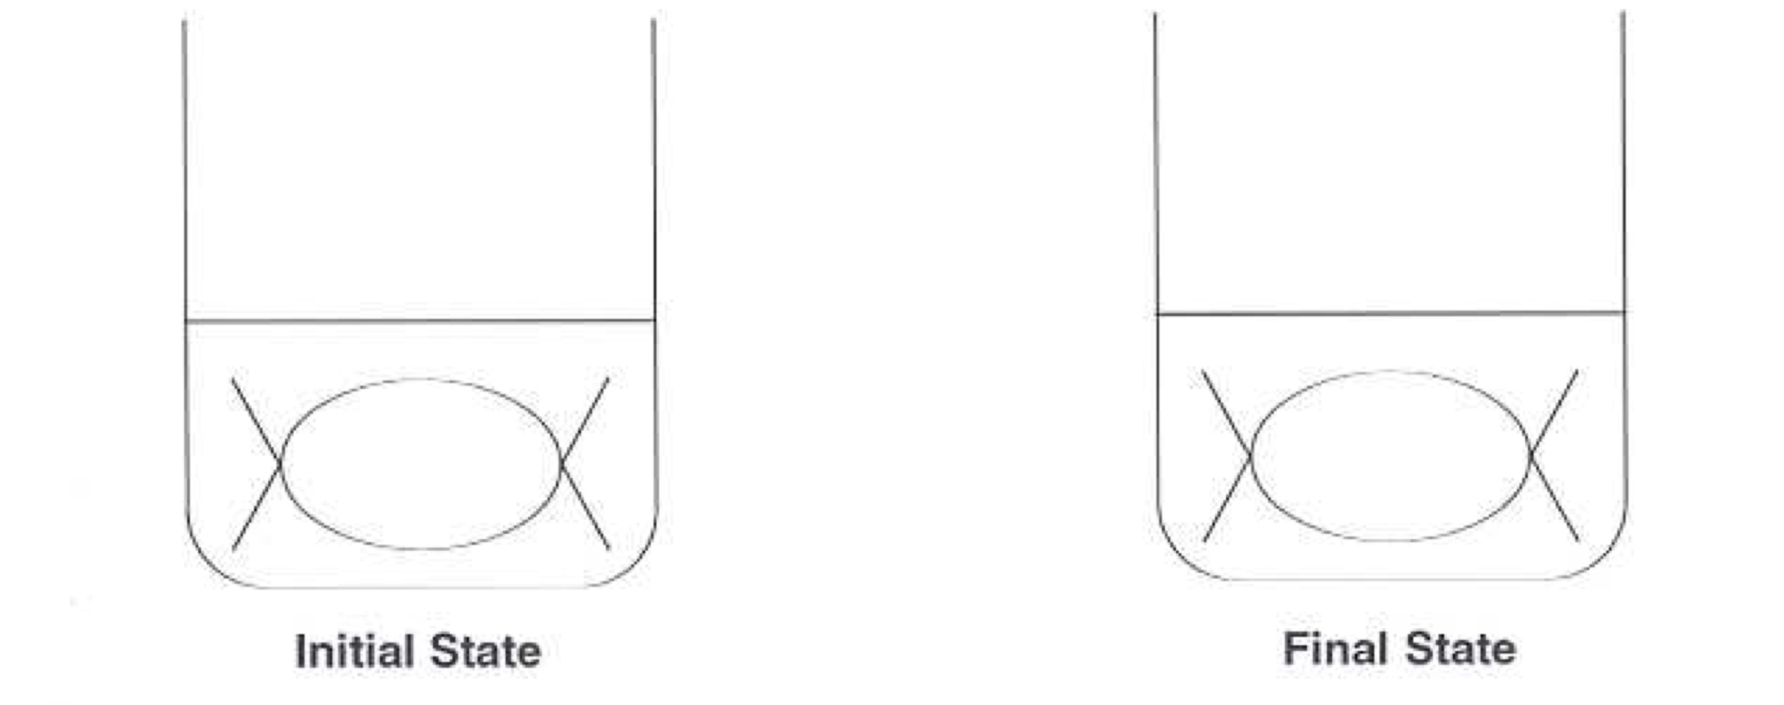
QUESTION 3: What changes did you observe in the final state?
__________________________________________________________________________________________________________________________________________________________________________________________________________________________________________

Part 2: Testing Indicator Solutions
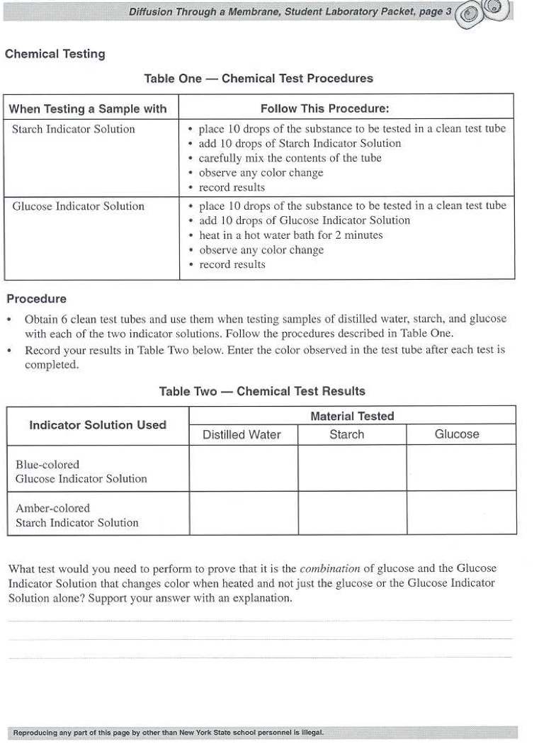
Benedict’s Solution
Lugol’s Iodine Solution

Part 3: Analyzing Results
Procedure
- Look at the cell we set aside earlier.
- Ms. Clark will use a pipette to transfer 10 drops of solution from outside of the cell into a new test tube and test for GLUCOSE with BENEDICT’S SOLUTION
QUESTION 4) Was there any glucose in the solution outside of the cell?
QUESTION 5) Fill in the “Final State” in Diagram 1.0 on page 2.
QUESTION 6) Why did the inside of the cell change color?
__________________________________________________________________________________________________________________________________________________________________________________________________________________________________________
QUESTION 7) Did any STARCH diffuse out of the cell? How do you know?
__________________________________________________________________________________________________________________________________________________________________________________________________________________________________________
QUESTION 8) Did any GLUCOSE diffuse out of the cell? How do you know?
__________________________________________________________________________________________________________________________________________________________________________________________________________________________________________
QUESTION 9) What molecules can move through the membrane?
__________________________________________________________________________________________________________________________________________________________________________________________________________________________________________
QUESTION 10) What molecules can NOT move through the membrane?
__________________________________________________________________________________________________________________________________________________________________________________________________________________________________________
QUESTION 11) Why could some substances diffuse through the membrane, while others were not able to?
__________________________________________________________________________________________________________________________________________________________________________________________________________________________________________

Part 4: Critical Thinking Questions
