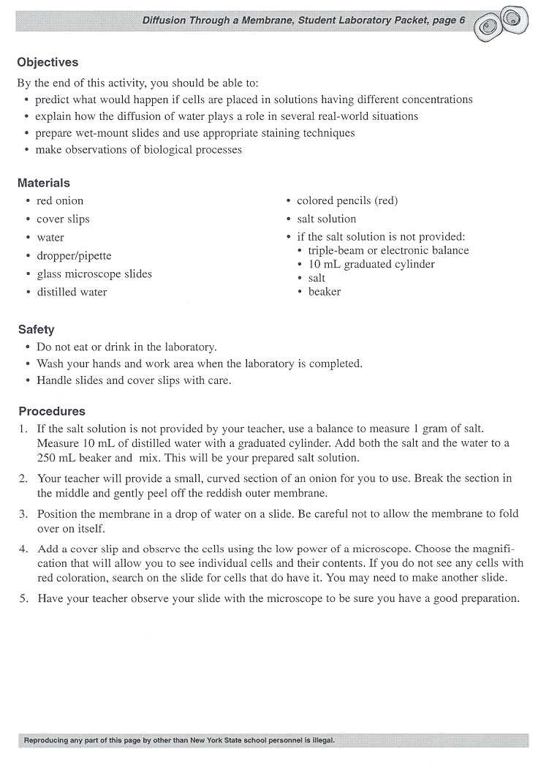
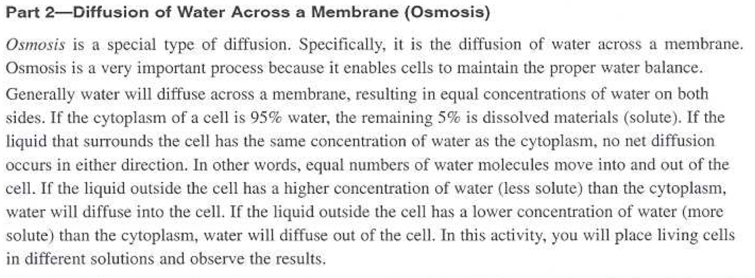
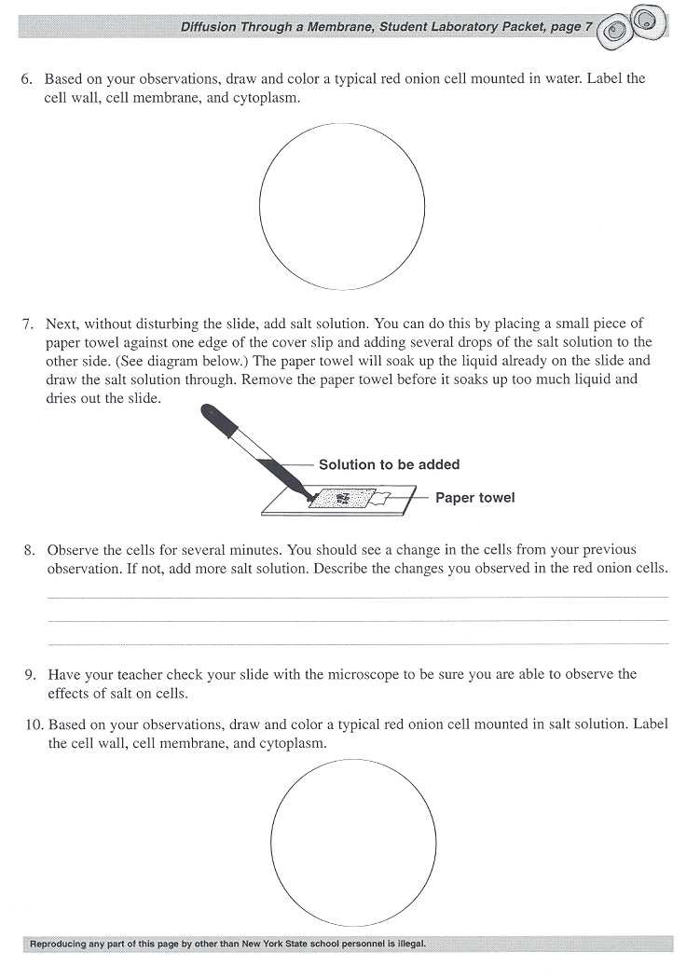

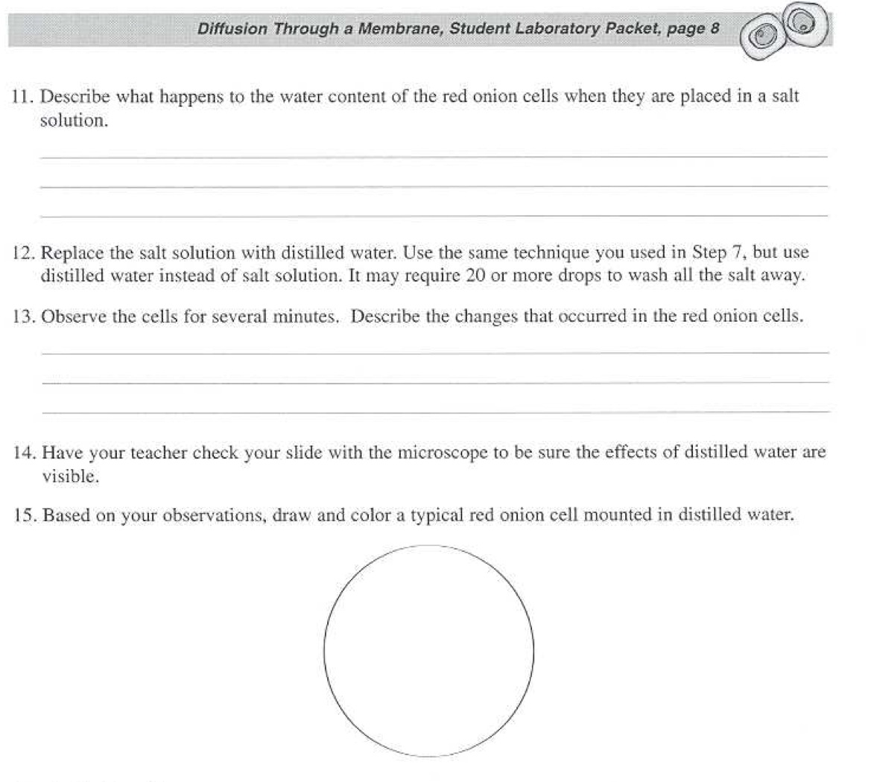
Analysis Questions: READ THE WHOLE QUESTION BEFORE ANSWERING!
- When a person in the hospital is given fluid intravenously (I.V.) the fluid is typically a saline (salt) solution with about the same water concentration as human body tissues. Explain how the used of pure water in place of this saline solution would hurt the patient and upset their homeostasis. You answer must include the word “DIFFUSION”

- Many fresh-water one-celled organisms have a structure called “contractile vacuoles.” Contractile Vacuoles pump out excess water that enters the cell. Name the process that causes water to flow into the one-celled organisms_____________________________ Explain why contractile vacuoles would be useless to one-celled organisms in the ocean (salt water)

- Popcorn at the movie theater is very salty, and it makes people very thirsty. This makes them buy soda. Describe in scientific terms why the salty popcorn makes people thirsty. What body cells do you think are affected?

