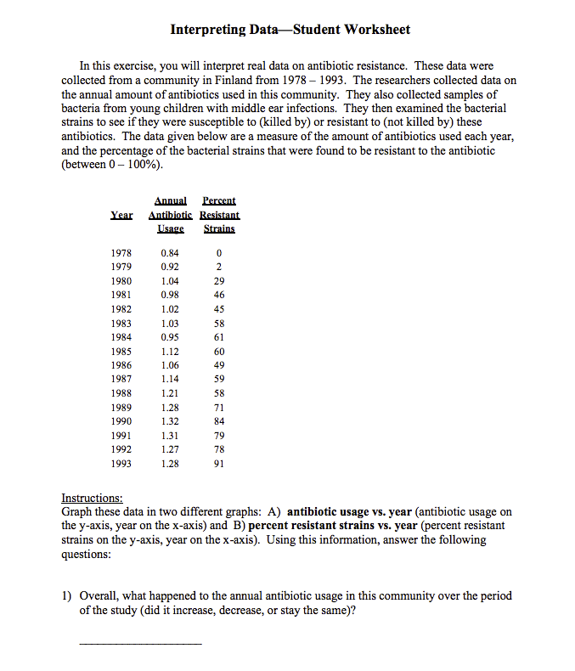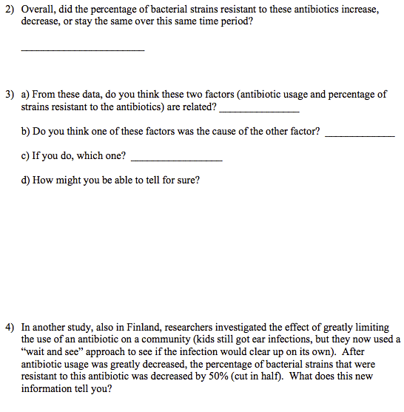

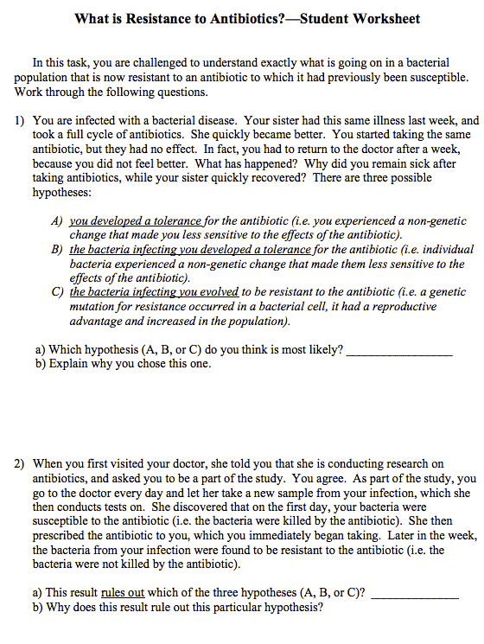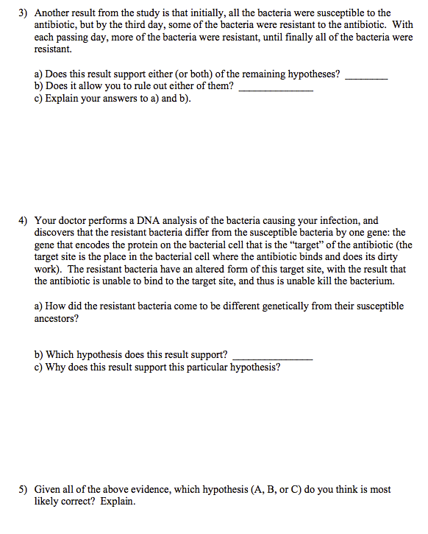

Name:_________________________________________________________ Date:_______________ Period:__________

Antibiotic Resistance
Directions: Each person in your group will read one section (in the boxes) and the conclusion. You will be responsible for summarizing your section to the other people in your group during the “turn and talk” portion of the lesson. Summarize each section below

Section 1

Section 2

Section 3

Section 4

Conclusion

What is Resistance to Antibiotics?

SECTION 1

Antibiotics are not as effective at killing bacteria as when they were first introduced. People are dying from infections that were easily treated just a few years ago. It has been estimated that infections caused by resistant bacteria kill as many as 77,000 people every year in the United States alone. Resistance to antibiotics costs dollars as well as lives: it costs the nation up to $30 billion every year. What happened? Why can we no longer cure infections that were very easily treated just a few years ago?

There are several ways to address this question. First of all, there is a prevalent misconception that antibiotics no longer work because the people who take the drugs have developed a tolerance for the drug. This is not the case. Humans do not develop a tolerance for antibiotics. Antibiotics work by inhibiting or killing the bacteria living inside of us. The reason they no longer work (i.e. we do not get better after taking the antibiotic) is that the bacteria are no longer inhibited/killed by the drug—they are resistant to the effects of the antibiotic.

So, back to our question, what is resistance to antibiotics? Let us first address this question physiologically. There are several ways that bacteria resist the effects of antibiotics. Some resistant bacteria inactivate the antibiotic by destroying or modifying the drug itself so that it is no longer toxic. Some resistant bacteria pump the drug out of the bacterial cell so that the concentration of the drug is too low to be effective.

SECTION 2

Now, let us address this question on a different level: Mutations that allow the bacteria to resist the effects of the antibiotic occur and have a selective advantage. These mutations have the type of effects that were described in the previous paragraph (for example, there is a mutation that results in an altered form of the target site). These resistance characters are often simple mutations (i.e. changes in a single gene). The result is that resistant bacteria differ genetically from their susceptible ancestors.

So what happens if a bacterial cell has a mutation that allows it to resist the effect of an antibiotic? If that bacterium is in the presence of the antibiotic, then it will have an advantage: the drug will not kill it! It will be able to reproduce, while the susceptible bacteria (which are inhibited or killed by the antibiotic) will not. In the presence of the antibiotic, the resistant mutant has a selective (reproductive) advantage over normal cells. Originally, most or all bacteria in the population were susceptible to the antibiotic. Over many generations, the resistant type will make up a greater and greater percentage of the population. Eventually, most or all of the individuals in the bacterial population will be resistant to the antibiotic.

Why Does Resistance Evolve so Quickly?

SECTION 3

Bacterial populations can evolve resistance very quickly. For example, in one hospital, initially 5% of the strains of staphylococcal bacteria were resistant to the antibiotic ciprofloxacin. Within one year, 80% of the bacterial strains were resistant. From 5% to 80% in one year! Why do bacterial populations evolve resistance so quickly? There are two basic reasons:

1) in general, bacteria have the capacity to evolve quickly

2) humans are helping them to evolve even faster

Bacteria Biology

There are several aspects of bacteria biology that contribute to their capacity for rapid evolution. Bacteria, relative to humans, have very short generation times. A generation time is the time it takes to go from one generation to the next. For example, in humans, it takes on average about 20 years to go from the birth of a child to the birth of that child’s child. Therefore, the generation time for humans is approximately 20 years. Contrast this with the average bacterial generation time of hours or even minutes! These colonies can have so many individual cells that, within hours or days, it will be large enough to see with the naked eye. Organisms with fast generation times, like bacteria, have the capacity for very rapid adaptation to a
changing environment. The more an organism reproduces, the greater chance for mutations to arise. Some mutations allow bacteria to become resistant to antibiotics.

To summarize, bacterial populations evolve resistance to antibiotics so quickly because of their fast generation times, large population sizes, and unique methods of gene acquisition. These are some of the reasons that bacteria have been so evolutionarily successful.

SECTION 4

Human Behavior

The second reason that bacterial populations evolve resistance to antibiotics so quickly is that several aspects of human behavior actually contribute to their capacity to evolve rapidly. Understandably, when antibiotics first became available, people started to use them. A lot. Today, antibiotics are overused, and unfortunately antibiotics are often misused.

Overuse:

- It has been estimated that nearly half of all medical prescriptions for antibiotics in the U.S. are unnecessary. Many doctors prescribe antibiotics under pressure from their patients, even if the antibiotic is not warranted (e.g. for a viral infection). Direct-to-consumer marketing by pharmaceutical companies can also lead to inappropriate demand for antibiotics by patients.
SECTION 4…
- Almost half of all antibiotics produced in North America and Europe are given to livestock; most are given not to fight infection, but prophylactically to promote growth in healthy animals. There is growing evidence that this use of antibiotics in livestock leads to resistance in human bacteria.

- It is currently trendy to include antibacterial agents in common household cleaning products (even hand lotion!). It is becoming more and more difficult to find cleaners without antibacterial agents.

Misuse:

- Medical doctors, including veterinarians and dentists, often incorrectly prescribe antibiotics: they prescribe the wrong antibiotics or the incorrect dosage of an antibiotic for a particular infection; they prescribe antibiotics for non-bacterial infections (e.g. colds, coughs, or influenza); they prescribe antibiotics prophylactically (in a low dosage for months at a time to prevent future infections; for example, for young children with a history of multiple ear infections).

- Many doctors also prescribe broad-spectrum antibiotics, which kill many different types of bacteria, rather than run a diagnostic lab test so they can prescribe a narrow spectrum antibiotic that would specifically target the bacteria causing the infection.

- In many other countries, antibiotics are freely available over the counter, without a doctor’s prescription, leading to widespread misuse.

- Patients themselves also contribute to the problem when they feel better after a few days, and then stop taking the antibiotics, instead of continuing with the full cycle prescribed to them. In a 1995 Gallup poll, it was estimated that more than half of American adults taking antibiotics failed to complete their prescribed dosage.

ALL READ
In addition, by using antibiotics incorrectly, we are giving the bacterial populations the opportunity to adapt quickly. For example, if you take an antibiotic correctly—in an adequately high dosage and for the entire cycle—most of the bacteria in your system will be killed. By greatly reducing the population size of the bacteria, you greatly decrease the chance that any one bacterium will mutate to a resistant form. However, if you incorrectly take the antibiotic—if you stop taking it after a few days or if the dosage is not high enough—more of the bacteria will survive. Higher numbers of bacteria means a greater chance that a resistance mutation will occur in any one of the bacterial cells. When these mutations do occur, they rapidly increase in the population, due to the very strong selection pressure exerted by the presence of the antibiotic.

In conclusion, the combination of several aspects of bacterial biology (fast generation time, high population sizes) and human behavior (heavy use of antibiotics, misuse of antibiotics) has led to an ever-increasing problem of bacteria resistant to our only means of controlling them.

