Name: _______________________________ *PUT NAME ON BACK PAGE AS WELL
Date:_____________ Period:___________

Fetal Pig Dissection
Classroom Rules
1) No food or drink in the lab.
2) Follow directions the first time they are given.
3) No unauthorized dissections
4) Wash and dry the equipment you use during the dissection. Wash and dry
you desk at the end of the hour.
5) Bring your copy of the lab activity and the Pig Dissection Rules & Regulations
to class every day.

Everyday Procedures

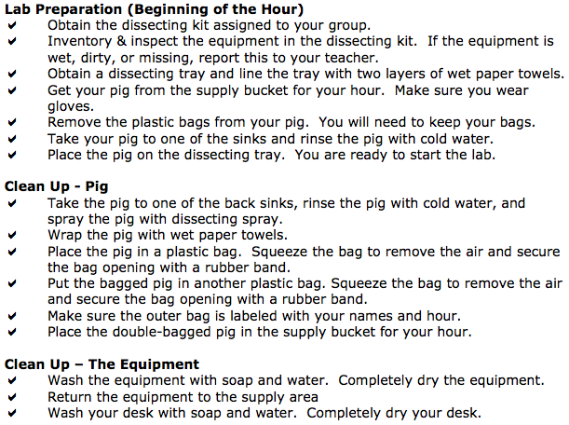

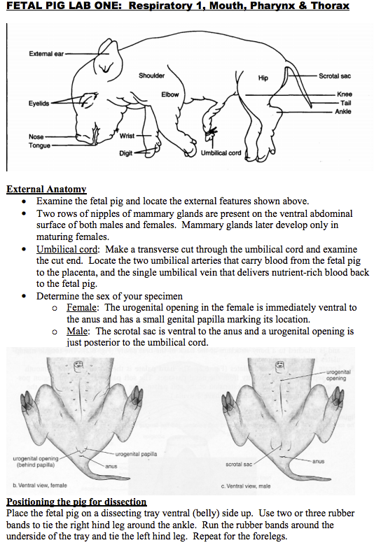
Lab 1 Questions:
- Is your pig male or female?

- How do you know the sex of your pig?

- What is the purpose of the umbilical cord?

- What organs do you infer the umbilical cord is next to? Why?

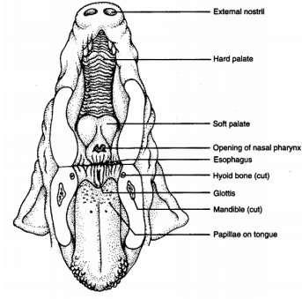
Lab 2: Oral Cavity
- Place the fetal pig on a dissecting tray ventral (belly) side up. Use two or three rubber bands to tie the right hind leg around the ankle. Run the rubber bands around the underside of the tray and tie the left hind leg. Repeat for the forelegs.
- Start by inserting a pair of scissors in the angle of the lips on one side of the head and cut posteriorly through the cheek
- Open the mouth as you make your cut and follow the curvature of the tongue to avoid cutting the roof of the mouth
- Now, repeat the procedure on the other side so that the lower jaw can be pulled down to expose the structures of the mouth and pharynx as shown
- Refer to page 3 in the table lab to identify the structures
Lab 2 Questions:
- Why are the senses of taste and smell important to organisms?

- Why do think the incisors (front teeth) of rodents (such as mice and rats) are so large and never stop growing? Why do pigs and humans not need these large incisors?

- How does the tongue aid in eating?

- The esophageal opening is the top of which tube? Where does it lead?

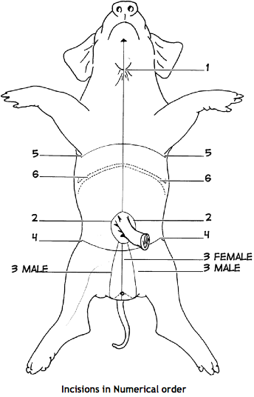
Lab 3 Digestive System
- Follow the directions below for making each of the cuts indicated on diagram at the right.
- Begin at the small hairy papilla on the upper part of the throat and continue posteriorly to the umbilical cord.
- Cut around both sides of the umbilical cord.
- If your pig is female, make one cut just posterior to the cord and continue back between the hind legs. (3Female). If you pig is male, instead of bring the cuts (2) together behind the cord, continue the two incisions posteriorly between the hind legs (3Male).
- Continue to deepen the incisions until the body cavity is reached. If the cavity is filled with a dark fluid, flush it out with water.
- Cut through the body wall just in front (anterior) of the hind legs Cut through the body wall just posterior to the fore legs. Cuts 4 and 5 produce lateral flaps that can be pinned out of the way.
- Free the diaphragm from the body wall by cutting the edge of the diaphragm where it is in contact with the body wall.
- Identify the Organs listed on page 6 in table lab.

Lab 3 Questions:
- To what organ does the umbilical vein lead?
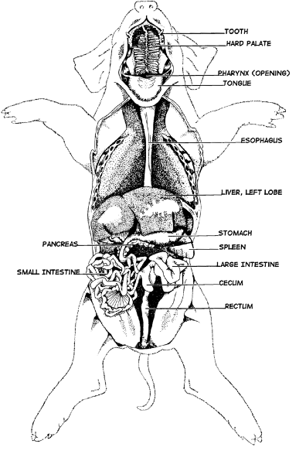

- List the function of each organ below
- Stomach
- Esophagus
- Small intestine
- Large intestine
- Pancreas
- Liver
- Gal bladder
- How do enzymes produced in the pancreas (insulin) come in contact with food since food does not pass through the pancreas?

Lab 4 Circulatory and Respiratory System
This system consists of the heart, arteries which carry blood away from the heart, and veins which carry blood toward the heart.
- Study the features of the heart without removing it
- Remove the thin and tough membrane, the pericardial sac, which encloses the heart.
- Note the four chambers of the heart from external view. These consist of right and left thin-wall atria and the much thicker right and left ventricles
- Identify the veins (Blue) in the head, neck, abdomen and appendages (page 11 in table lab). They empty into the anterior vena cava and into the right atrium of the heart
- Identify the right and left ventricles, notice a large vessel emerging from each one.
- Identify the arteries (red) in the head neck abdomen and appendages (page 14 in table lab). Oxygenated blood leaves the heart through the aorta and goes to the rest of the body

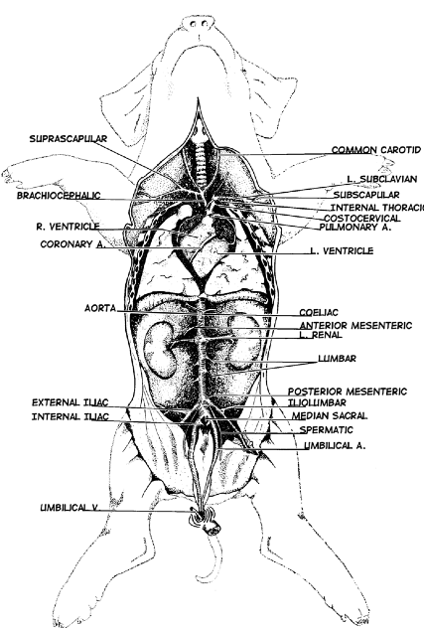

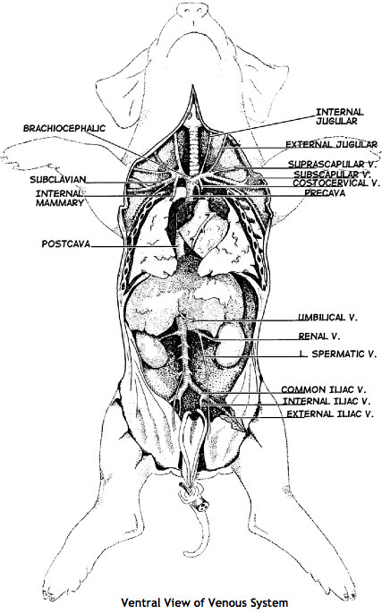

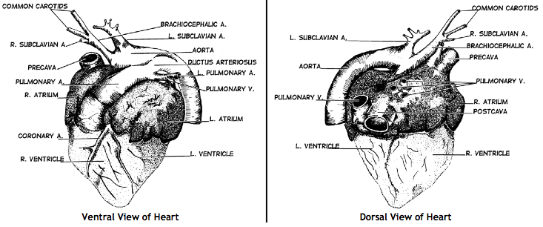

7. Push the heart to one side to expose the branching of the trachea into bronchioles.
- Gently pull lungs forward and observe the texture and the blood vessels around them
- Refer to pages 18-19 in the table lab to identify other structures

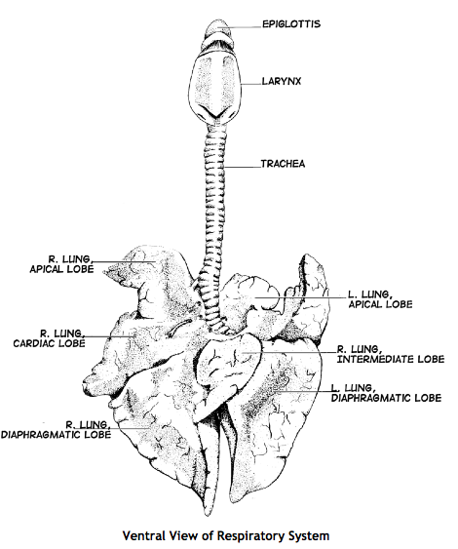
Lab 4 Questions:

- How does oxygen in the lungs get to the blood?

- Why is the trachea constructed with rings of cartilage?

- What is the primary function of the respiratory system

- Carbon dioxide is exhaled from the lungs. How is it produced?

- What other substances does the blood circulate throughout the body?

- List body systems, other than respiratory, that depend on the circulatory system? Describe one in detail.

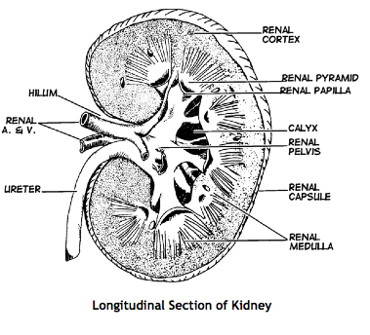
Lab 5: Urogenital System (Excretory and Reproductive)
- Identify the two dark brown kidneys.
- Follow the tube running from the kidneys to the tail end. This is the ureter.
- Carefully slice open one kidney, as show on the right, without removing it.
- If you have a male, the ureter will flow into the urethra in the penis. In the penis you will see another tube, the vas deferens, that runs back to the testis .
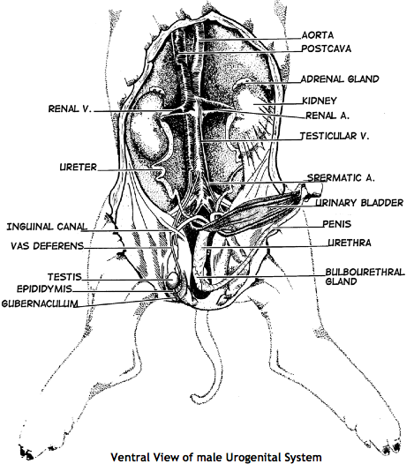
- If you have a female, below the two kidneys you may find two ovaries with 2 fallopian tubes running to a small uterus.
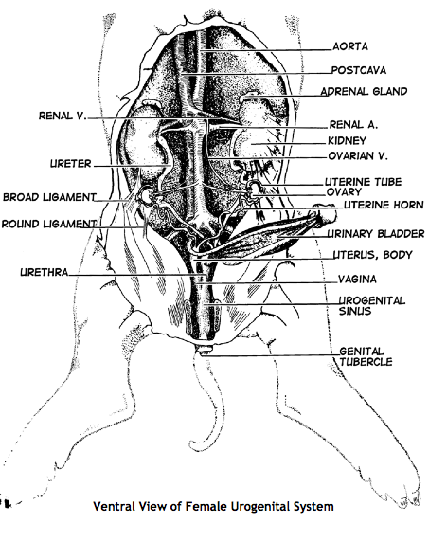
- Refer to page 20- end in table lab

Lab 5 Questions
- What substance is carried out through the urethra?
- List the function for each of the following and write whether each is a male or female structure
  - Ovary
  - Testis
  - Vagina
  - Urethra
  - Urinary bladder
  - Kidney
- Why is the scrotum important?

- Kidneys are important organs. What helps to project the kidneys within the pigs body?

Fetal Pig Dissection Rubric
Name: ___________________________________________
Period:___________ Date:_________________________

I can use dissection equipment safely | 1 | 2 | 3 | 4 | (CHAH: I show self control)
I can follow written directions carefully, and dissect neatly | 1 | 2 | 3 | 4 | (CHAH: I am accountable)
I can correctly identify organs and place them correctly on the laminated guide | 1 | 2 | 3 | 4 | (LE 4.2: I can identify the structures and functions of body systems)
I can answer Lab questions accurately and make connections between the pig systems and human systems | 1 | 2 | 3 | 4 | (LE 4.2: I can identify the structures and functions of body systems)
 |  |  |  |  | LE 4.2 Total
Lab by Morgann Clark 3/3/2015
Sources
http://amhs.ccsdschools.com/common/pages/DisplayFile.aspx?itemId=19454149
http://www.mychandlerschools.org/cms/lib6/AZ01001175/Centricity/Domain/3402/Pig%20disection%20packet.pdf

