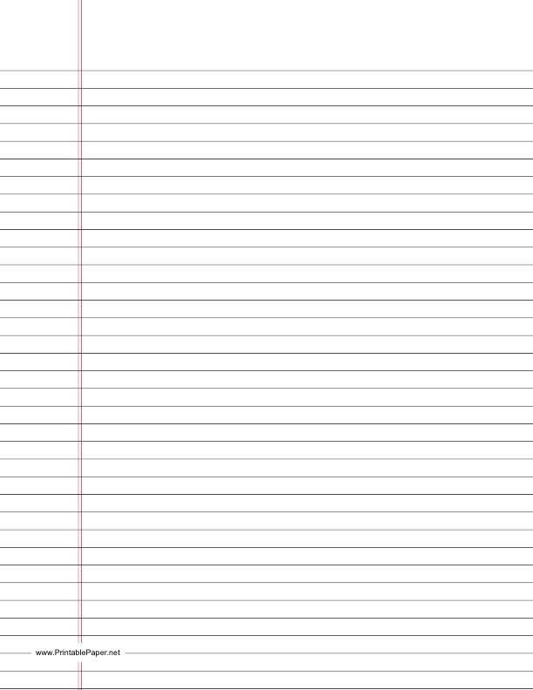

**Excellent Report Example!**

Ms. Clark Seat#: T1 10/2/12

Living Environment Period 4

Adult and Children Sour Preference

Lab Group T: Mr. Gooden and Mr. Garamella

Experimental Question: Is there a difference in sour preferences of adults and children?

Hypothesis: If different age groups are given three difference glasses of lemonade with varying

levels of sourness, then more children will show preference for the sour lemonade than the adults,

because children prefer novel and interesting stimuli.

Materials:

20 test subjects for the following age groups (0-10, 11-20, 21-30, 31-40, 41-50, 51-60)

2 Gallons of extra sour lemonade

2 Gallons of regular lemonade

2 Gallons of extra sweet lemonade

120 Copies of the preference survey

Safety: It is important to consider possible allergies the test subjects may have toward the

beverages being tested. Also, beverage servers should wear gloves for sanitation. Parental

consent must be given by a parent or guardian for a children under the age of 18 to participate.

Procedure:

Independent Variable: The different age groups

Dependent Variable: Number of participants who prefer sour, regular and sweet

Lemonade

Constants: Same amount of liquid, same number of participants per age group, same

survey, same beverage samples given to each participant

Control: Regular Lemonade

Steps:

1) Participants of first age group were assembled

2) Each participant is given a sample of regular lemonade, sour lemonade and

sweet lemonade



3) After sampling each beverage, the participants indicate their favorite on the survey.

4) Data is collected

5) Steps 1-4 are repeated for each age group

6) Analyze data

Data:

**Age Group’s Preference for Sour Taste in Lemonade**

|  |  |  |  |
| --- | --- | --- | --- |
| Age Group | Number of people who prefer **extra sour** lemonade | Number of people who prefer **regular** lemonade | Number of people who prefer **extra sweet** lemonade |
| 0-10 | 10 | 6 | 4 |
| 11-20 | 9 | 7 | 4 |
| 21-30 | 6 | 11 | 3 |
| 31-40 | 5 | 10 | 5 |
| 41-50 | 5 | 9 | 6 |
| 51-60 | 4 | 9 | 7 |
| 61-70 | 3 | 7 | 10 |

Conclusion*:* The data collected during the experiment agrees with the hypothesis. More children,

especially those 1-20 years, prefer sour flavors over regular or sweet. Adults, particularly those

between the ages of 61 and 70 prefer sweet flavors. To better understand why more children

show a preference for sour flavors, another experiment would have to be made. In the future one

could ask participants to fill out a survey that asks for their personal reaction to the flavors. For

example, “It is fun to eat sour thing” or “Sour food hurts my tongue” or “I just like the flavor.”

**Heading**: Name: Seat # Date:

Living Environment Lab Group: Period:

**Title:** *Title of the Lab*

**Experimental Question:** *What question will this lab answer?*

**Hypothesis:** *What is your prediction for this lab?*

If____________________ , then__________________________________ because________________________

**Materials:**  *In this lab I will need to use…*

**Safety:** *Some safety concerns we need to be aware of are….*

*In this lab you should wear….*

*Be careful with….*

**Procedure:**

**Independent Variable:** *What was changed on purpose in this experiment?*

**Dependent Variable:**  *What is the responding variable? What was measured in this experiment?*

**Constants:** *What are you going to make sure is this same in each trial? What will make sure that your experiment is valid?*

**Control:** *The group that gets the same variables as all the other trials, except it doesn’t have the Independent Variable What will you be comparing your experimental trials to?*

**Clear Steps:** *Should be written in 3rd Person past tense (no “I” or “We”)*

*1)First this step was done*

*2)Next, this was completed*

*3) Then…*

**Data:** *Charts and Graphs*

REMEMBER: *Bar graphs are used to* ***compare****, Line graphs are used to show a* ***relationship***

ALL GRAPHS NEED*: 1) Title 2) X and Y axis Labels 3) Even scales (#’s) on the X and Y axis 4) Be neat*

*Use pencil. Color is nice.*

**Conclusion:** *Your conclusion should have two parts:*

***1)*Relate to your hypothesis. Try one of these sentence starters.**

*The data show that my hypothesis was incorrect/correct because…*

*The graph shows…*

*There is a significant difference between…*

*There is a positive/negative correlation between…*

***2)*Make a proposal for a future experiment or describe what you would do differently if given the chance.**

*A further study could be…*

*In the future I would like to…*

*One thing I would do differently is…*

*This experiment inspires me to…*