Nitrogen Cycle: cycling of nitrogen between organisms, soil, water and the atmosphere
–Organisms can’t use nitrogen gas, but need other forms of nitrogen to make proteins
•Fixed Nitrogen = __________________________________________________________________
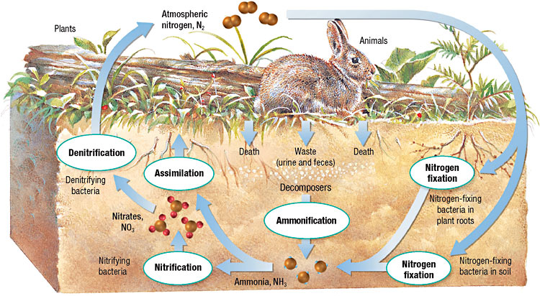
•Unfixed Nitrogen = _______________________________________________________________

1._______________________________________________________________________________________________________________________________________________________________________________________________________________________________________________________________________________________________________________________________________________________________________________
2._______________________________________________________________________________________________________________________________________________________________________________________________________________________________________________________________________________________________________________________________________________________________________________
3._______________________________________________________________________________________________________________________________________________________________________________________________________________________________________________________________________________________________________________________________________________________________________________
4._______________________________________________________________________________________________________________________________________________________________________________________________________________________________________________________________________________________________________________________________________________________________________________
5._______________________________________________________________________________________________________________________________________________________________________________________________________________________________________________________________________________________________________________________________________________________________________________
Water Cycle: moves water between atmosphere, land and oceans.
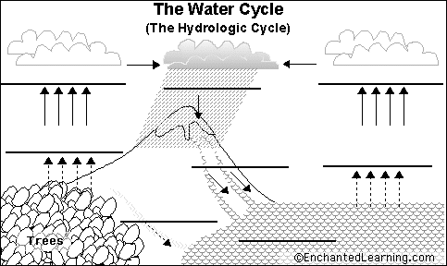
- Evaporation________________________________________________________________________________________________________________________________________________________________________________________________________________________
- Condensation______________________________________________________________________________________________________________________________________________________________________________________________________________________
- Precipitation_______________________________________________________________________________________________________________________________________________________________________________________________________________________
- Transpiration______________________________________________________________________________________________________________________________________________________________________________________________________________________
- Run off___________________________________________________________________________________________________________
_______________________________________________________________________________________________________________________
- Accumulation______________________________________________________________________________________________________________________________________________________________________________________________________________________

Name: Seat: Date:

Living Environment Period:

Directions: Read the following article and respond in your own words

How Humans Affect the Water Cycle of Toronto, Canada
The Credit River Watershed is part of a larger picture – the greater Toronto bioregion. This region is bounded on the west by the Niagara Escarpment, on the north and the east by the Oak Ridges Moraine and on the south by the north shore of Lake Ontario. Every time humans interrupt the natural water cycle there will be an effect.
We interrupt water pathways in two ways:
1. Withdrawals: We take water out of the system to irrigate crops, to provide us with drinking water and to carry out many of our industrial processes.
2. Discharges: We add substances to the water – intentionally or not. As precipitation falls on the ground and moves into rivers and creeks, it picks up a whole range of pollutants. In rural areas these pollutants may include farm pesticides, herbicides and fertilizers as well as wastes from faulty septic systems and improperly handled manure. In urban areas, the pollutants may include gas, oil, pet waste, fertilizers, pesticides, salt and treated human waste from sewage treatment plants.
What we do to this system affects everything within it. For example, what happens if rain that falls from the sky or the water that flows through our streams is contaminated? These contaminants may infect plant or animal life including human beings, or reduce their ability to grow and reproduce. What happens if large quantities of water are diverted or taken out of the system? The reduced flow will likely affect the local water supply but it may eventually change the local environment and alter the plant and animal species that are found here. As we place different stresses on this system, we run the risk of altering or overloading it and causing serious harm.
The Credit River is an important part of the watershed and the water cycle in this area. What we do here affects us locally and eventually affects the health of the water and the communities nearby, including people living in the cities of Brampton, Mississauga, Toronto and others bordering Lake Ontario.

1) How do humans interrupt the water cycle?

2) What are the consequences of too much water withdrawal and discharges on the ecosystem?

Directions: Read the following article and respond in your own words

Human alteration of the Nitrogen cycle and its environmental consequences

Early in the 20th century, a German scientist named Fritz Haber figured out how to short circuit the nitrogen cycle by fixing nitrogen chemically at high temperatures and pressures, creating fertilizers that could be added directly to soil. This technology has spread rapidly over the past century, and, along with the advent of new crop varieties, the use of synthetic nitrogen fertilizers has led to an enormous boom in agricultural productivity. This agricultural productivity has helped us to feed a rapidly growing world population, but the increase in nitrogen fixation has had some negative consequences as well. While the consequences are perhaps not as obvious as an increase in global temperatures or a hole in the ozone layer, they are just as serious and potentially harmful for humans and other organisms.
Not all of the nitrogen fertilizer applied to agricultural fields stays to nourish crops. Some is washed off of agricultural fields by rain or irrigation water, where it leaches into surface or ground water and can accumulate. In groundwater that is used as a drinking water source, excess nitrogen can lead to cancer in humans and respiratory distress in infants. The U.S.Environmental Protection Agency has established a standard for nitrogen in drinking water of 10 mg per liter nitrate-N. Unfortunately, many systems(particularly in agricultural areas) already exceed this level. By comparison, nitrate levels in waters that have not been altered by human activity are rarely greater than 1 mg/L. In surface waters, added nitrogen can lead to nutrient over-enrichment, particularly in coastal waters receiving the inflow from polluted rivers. Nitrogen from fertilizers is washed away by run-off water and trickles into larger bodies of water. This is called eutrophication. It has been blamed for increased deaths in fish and increased frequencies of harmful algae blooms. If there is extra nitrogen in the water, the algae will grow too fast and leave a film on top of the water. This blocks sun from getting to other water plants that plankton and fish need to eat. Obviously, disrupting the nitrogen cycle can disrupt the food web too.

- How do humans interrupt the nitrogen cycle?

- What are the consequences of fertilizers getting into our water?

