LET THEM EAT CAKE!
Yeast is used in baking to make breads and cakes rise. Yeast takes the sugar found in the dough/batter and converts it into carbon dioxide and alcohol (C₂H₅OH). No oxygen is involved in the reaction. It's the release of carbon dioxide in this reaction, leaving gas pockets behind, which makes the bread or cake fluffy and airy.
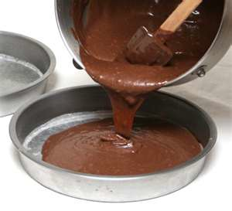
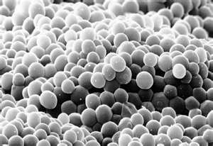
=
+

Answer the following questions in the corresponding section of your handout.

- Write the chemical equation for the reaction described above

- Is the reaction aerobic or anaerobic? How do you know?

- Is this an instance of cellular respiration or fermentation? How do you know?

DON’T HOLD YOUR BREATH!
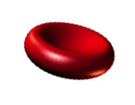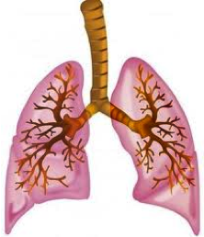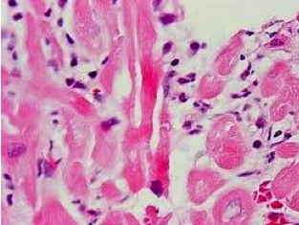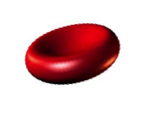 When you breathe, you inhale oxygen and exhale carbon dioxide through your lungs. Inside your lungs, oxygen is taken up by your red blood cells, which carry the oxygen to all the cells throughout your body. On their return trip to your lungs, your red blood cells take up the carbon dioxide your cells have produced via cellular respiration. After returning to your lungs, your red blood cell release they carbon dioxide they are carrying, which you exhale. The red blood cells then continue on their next trip through your body!
Red blood cells with O₂
Red blood cells with CO₂

- Write the chemical equation for cellular respiration on the line provided (using chemical formulas).

- Rewrite the equation for the reaction using words rather than chemical formulas.

- What gas is required for cellular respiration to occur?

- What gas is produced by cellular respiration?

- Where in your body do you take in O₂ and get rid of CO₂?

- Where in your body to you use O₂ and produce CO₂?

