Living Environment
Unit 5: Reproduction

Name________________________________________ Period: __

HW 22 5.2 Asexual Reproduction

Directions: Use your notes and knowledge of biology to answer each question. Ask questions if you have them.

1. The diagram below illustrates asexual reproduction in bacteria.
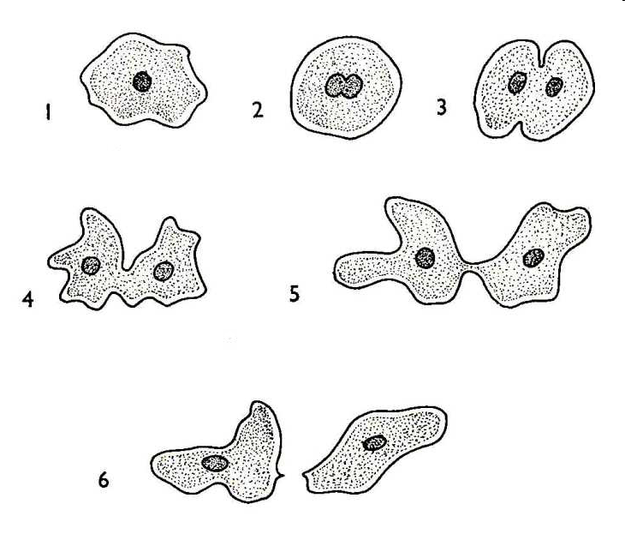
Bacteria produce offspring that usually have
- genes that are different from those of the parent
- genes that are identical to those of the parent
- half of the genetic information
- organelles that are no found in the parent

2. A tree produces only seedless oranges. A small branch cut from this tree produces roots after it is planted in the soil. When mature, this new tree will most likely produce
(1) oranges with seeds, only (3) a majority of organs with seeds and only a few without
(2) oranges without seeds, only (4) oranges and other kinds of fruit

3. Raspberries can reproduce by means of runners, which are stems that grow horizontally above the ground. At the region of the runner that touches the ground, a new plant develops. The new plant is genetically identical to the parent because
(1) it was produces sexually
(2) nuclei traveled to the new plant through the runner to fertilize it
(3) it was produced asexually
(4) there were no other rasp berry plants in the area to provide fertilization

4. A certain bacterial colony originated from the division of a single bacterial cell. Since they have the same DNA, each cell in the colony will most likely
(1) express adaptations unlike those of the other cells
(2) replicate different numbers of genes
(3) have a resistance to different antibiotics
(4) synthesize the same proteins and enzymes

5. The diagram below illustrates asexual reproduction in yeast.
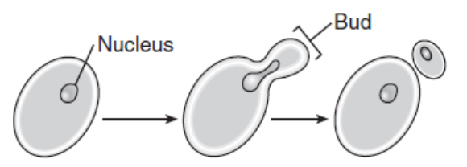
Yeast produce offspring that usually have
- genes that are different from those of the parent
- genes that are identical to those of the parent
- half the genetic information of the parent
- organelles that are found in the parent

6. A pattern of reproduction and growth in a one-celled organism is shown below.
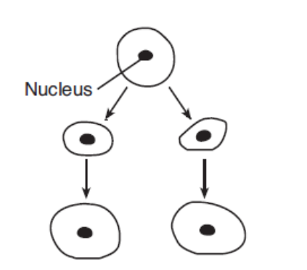

Which statement best describes this pattern of reproduction?
- All genetic material comes from one parent.
- Only some of the genetic material comes from one parent.
- The size of the parent determines the amount of genetic material.
- The size of the parent determines the source of genetic material.

7. Thousands of genetically identical trees have been discovered growing in a remote, undisturbed mountain area in Colorado. These trees are most likely the result of
(1) genetic engineering
(2) asexual reproduction
(3) meiotic cell division
(4) biotechnology

8. A new hydra can be produced from groups of cells that enlarge and stay attached to the parent hydra for a time before breaking off and becoming independent. This method of reproduction is called
(1) sporulation (3) binary fission
(2) cloning by runners (4) budding

9. In binary fission, the genetic material is supplied by
(1) one daughter cell
(2) one parent cell
(3) two daughter cells
(4) two parent cells

