Compare & Contrast!
Process | Template | Product | Site | Purpose
Replication
Transcription
Translation

With your partner:
1. Match the numbered stages with the correct lettered descriptions below
1. transcription ____
2. replication ____
3. translation ____

A) stage during which information coded in the base sequence of DNA is read to produce a strand of mRNA
B) process during which the genetic code in RNA is used to make proteins
C) process in which strands of DNA are separated and each is paired with nucleotides in order to form two new strands of DNA

2. Fill in an mRNA codon that would code for each amino acid shown.
Amino acid: GLU - PHE - TRP
mRNA codon: ______ ______ ______

3. Which three codons would code for a different amino acid sequence from that coded for by the mRNA base sequence GGU-CGA-CUG
(1) GGU-AGA-CUG
(2) GGC-CGA-CUA
(3) GGU-CGU-CCG
(4) GGA-CGC-CUC

8. The sequence of bases below represents an entire strand of mRNA that is sent to the ribosome to construct a protein. However, during translation, not every codon will result in an amino acid. In the spaces below, write the first, second, and last amino acid that will appear in the protein.
CAU CGU AUG ACA AAU GAU UGA GCG

First AA ______ Second AA ______ Last AA _______
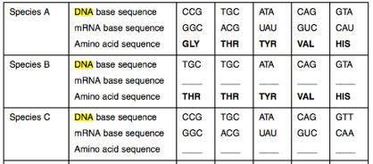

Living Environment TRANSCRIPTION AND TRANSLATION HW 30
Unit 6: Genetics

Name: _______________________________________________________

1. Three structures are represented in the diagram below.
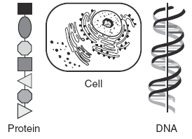
What is the relationship between these three structures?
(1) DNA is made up of proteins that are synthesized in the cell.
(2) Protein is composed of DNA that is stored in the cell.
(3) DNA controls the production of protein in the cell.
(4) The cell is composed only of DNA and protein.

2. Which of the following bases will not be present in a molecule of mRNA?
(1) Adenine (2) Guanine (3) Uracil (4) Thymine (5) Cytosine

3. What is the role of DNA molecules in the synthesis of proteins?
(1) They catalyze bond formation between amino acids. (3) They supply energy for protein synthesis.
(2) They determine the sequence of amino acids in a protein (4) They transfer amino acids to the nucleus

4. The end result of the process of translation is the production of
(1)DNA (2) Proteins (3) RNA (4) Inherited traits

5. The sequence of amino acids that makes up a protein is determined by the sequence of
(1) bases in DNA (2) amino acids in DNA (3) ribosomes in cytoplasm (4) glucose in the chloroplast

6. Base your answer to the question on the chart below, which represents a portion of the mRNA codon chart.
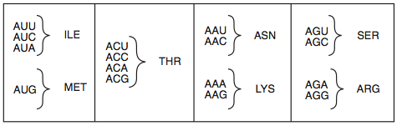
Complete the chart below with the mRNA codons and amino acids coded for by the DNA base sequence.
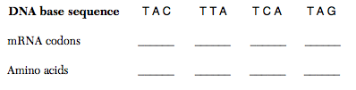
7. The sequence of bases below represents an entire strand of mRNA that is sent to the ribosome to construct a protein. However, during translation, not every codon will result in an amino acid. In the spaces below, write the first, second, and last amino acid that will appear in the protein.
CAU CGU AUG ACA AAU GAU UGA GCG

First AA ______ Second AA ______ Last AA _______

8. Molecule A never leaves the nucleus. Instead, the cell uses a different molecule, molecule X to carry the coded info contained in Molecule A to the ribosomes for processing. Molecule X is most likely: [1]
(1) DNA (2) ATP
(3) mRNA (4) DDT

