Living Environment
Unit 5: Reproduction

Name: ____________________________________ Period: _______ `Date:

CLASSWORK 5.3 Male & Female Reproductive Anatomy
Today’s AIM: How are human reproductive systems designed?

Directions: Answer the following questions to the best of your abilities using what you have learned today as well as your knowledge of biology.

Use the diagrams below to answer questions 1-3.
2
1
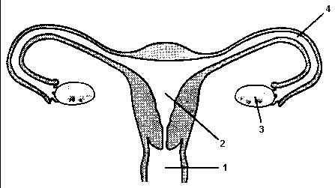
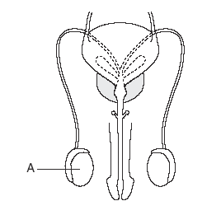

- Determine the sex represented in each diagram above.
1: ___________________ 2: ___________________

- Draw the pathway a sperm cell would travel through in each system during the process of sexual reproduction.

- Label the diagrams above with the following structures
Uterus; Testes; Urethra; Vagina; Ovary; Fallopian Tube; Penis

- ATP is important to sperm cells because it
(1) supplies the energy needed to move
(2) enables the cells to replicate and divide
(3) reduces their chromosome number
(4) doubles their chromosome number

- Removal of one ovary from a human female would most likely
- affect the production of eggs
- make fertilization impossible
- make carrying a fetus impossible
- decrease her ability to provide essential nutrients to an embryo

- Which reproductive structure is correctly paired with its function?
- uterus - usual site of fertilization
- fallopian tube - usual location for egg development
- ovary - delivers nutrients to the embryo
- egg cell - transports genetic material
Use the diagram below to answer questions 7-8, which depict the male and female reproductive systems as viewed in profile.
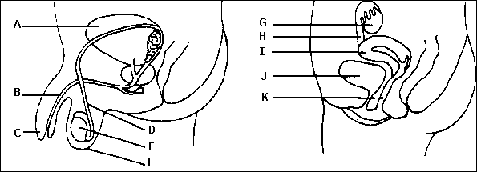

- In the diagram above, identify the letters representing structures directly involved in the production of male and female gametes. _________ & _________

- Base your answer on the diagram and your knowledge of biology. In humans, which structures are normally presented in pairs?
- structures B, C, K, and I
- structures D, E, G and H
- structures E, F, I, and G
- structures C, D, I , and K

Use the passage below to answer question 9.
Vasectomy

The number of vasectomies performed in the United States has increased substantially over the past 20 years. A vasectomy is a minor surgical procedure in which a surgeon intentionally severs the vas deferens in a male. This type of surgery is considered a “contraceptive procedure” because it eliminates the possibility of conception (fertilization) following sexual intercourse. Though the procedure is relatively safe it is generally considered irreversible.

- Briefly explain why a male who has undergone a vasectomy would be unable to impregnate a female.
_________________________________________________________________________________________________________________________________________________________________________________________________________________________________________________________________________________

- CHALLENGE QUESTION:
Identify the organ/structure in which a developing fetus undergoes mitosis during gestation (the 9 month period preceding birth).
___________________________________________________________________________________________

