Living Environment
Unit 6: Where do babies come from?

Name: ____________________________________ Period: _______ `Date:

HOMEWORK 6.2 Ectopic Pregnancy

Directions: Read and annotate the article below. Then answer the questions which follow on the back of this page.
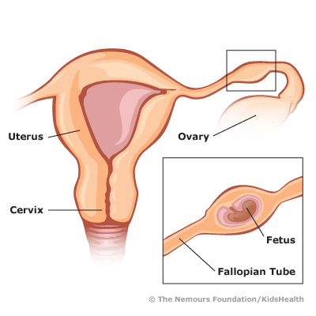
E
ctopic means "out of place." In an ectopic pregnancy, a fertilized egg has implanted outside the uterus. The egg settles in the fallopian tubes in more than 95% of ectopic pregnancies. This is why ectopic pregnancies are commonly called "tubal pregnancies." The egg can also implant in the ovary, abdomen, or the cervix, so you may see these referred to as cervical or abdominal pregnancies.

None of these areas has as much space or nurturing tissue as a uterus for a pregnancy to develop. As the fetus grows, it will eventually burst the organ that contains it. This can cause severe bleeding and endanger the mother's life. An ectopic pregnancy usually does not develop into a live birth.

Signs and Symptoms
Ectopic pregnancy can be difficult to diagnose because symptoms often mirror those of a normal early pregnancy. These can include missed periods, breast tenderness, nausea, vomiting, or frequent urination.
The first warning signs of an ectopic pregnancy are often pain or vaginal bleeding. You might feel pain in your pelvis, abdomen, or, in extreme cases, even your shoulder or neck (if blood from a ruptured ectopic pregnancy builds up and irritates certain nerves). Most women describe the pain as sharp and stabbing. It may concentrate on one side of the pelvis and come and go or vary in intensity.

Any of the following additional symptoms can also suggest an ectopic pregnancy:
- vaginal spotting - low blood pressure (also caused by blood loss)
- dizziness or fainting (caused by blood loss) - lower back pain

What Causes an Ectopic Pregnancy?
An ectopic pregnancy results from a fertilized egg's inability to work its way quickly enough down the fallopian tube into the uterus. An infection or inflammation of the tube might have partially or entirely blocked it. Pelvic inflammatory disease (PID), which can be caused by gonorrhea or chlamydia, is a common cause of blockage of the fallopian tube.

Endometriosis (when cells from the lining of the uterus implant and grow elsewhere in the body) or scar tissue from previous abdominal or fallopian surgeries can also cause blockages. More rarely, birth defects or abnormal growths can alter the shape of the tube and disrupt the egg's progress.

Some birth control methods can also affect your risk of ectopic pregnancy. If you get pregnant while using progesterone-only oral contraceptives, progesterone intrauterine devices (IUDs), or the morning-after pill, you might be more likely to have an ectopic pregnancy. Smoking and having multiple sexual partners also increases the risk of an ectopic pregnancy.

Diagnosis
If you arrive in the emergency department complaining of abdominal pain, you'll likely be given a urine pregnancy test. Although these tests aren't sophisticated, they are fast — and speed can be crucial in treating ectopic pregnancy.

If you already know you're pregnant, or if the urine test comes back positive, you'll probably be given a quantitative hCG test. This blood test measures levels of the hormone human chorionic gonadotropin (hCG), which is produced by the placenta (a structure which supports a developing embryo) and appears in the blood and urine as early as 8 to 10 days after conception. Its levels double every 2 days for the first several weeks of pregnancy, so if hCG levels are lower than expected for your stage of pregnancy, one possible explanation might be an ectopic pregnancy.

You'll probably also get an ultrasound examination, which can show whether the uterus contains a developing fetus or if masses are present elsewhere in the abdominal area. But the ultrasound might not be able to detect every ectopic pregnancy. The doctor may also give you a pelvic exam to locate the areas causing pain, to check for an enlarged, pregnant uterus, or to find any masses.

Even with the best equipment, it's hard to see a pregnancy less than 5 weeks after the last menstrual period. If your doctor can't diagnose ectopic pregnancy but can't rule it out, he or she may ask you to return every 2 or 3 days to measure your hCG levels. If these levels don't rise as quickly as they should, the doctor will continue to monitor you carefully until an ultrasound can show where the pregnancy is.

QUESTIONS

- Define the term “ectopic pregnancy” and identify the most common site of ectopic pregnancies in human females.
_______________________________________________________________________________________________________________________________________________________________________________________________________________________________________________________________

- Explain why ectopic pregnancies are considered dangerous for both a mother and a developing fetus.
_______________________________________________________________________________________________________________________________________________________________________________________________________________________________________________________________

- Identify three common early symptoms of an ectopic pregnancy.
_______________________________________________________________________________________________________________________________________________________________________________________________________________________________________________________________

- Identify 3 factors which may increase the risk of developing an ectopic pregnancy.
_______________________________________________________________________________________________________________________________________________________________________________________________________________________________________________________________

- Pretend you are a doctor working in an emergency room. A woman comes in complaining of symptoms which are related to ectopic pregnancy. Identify and describe two tests you could perform to definitively diagnose whether your patient has an ectopic pregnancy or not.
_______________________________________________________________________________________________________________________________________________________________________________________________________________________________________________________________
__________________________________________________________________________________________________________________________________________________________________________

