Living Environment
Unit 5: Where do babies come from?

Name: ____________________________________ Date: ____/10 Points

HW 25 Reproductive Hormones

Directions: Answer the questions below to the best of your abilities using your knowledge of biology.
- Estrogen, progesterone, and testosterone are all types of hormones, or chemical signals, which are received by which molecules involved in cellular communication?
(1) antigens (2) enzymes (3) nucleus (4) receptor molecules
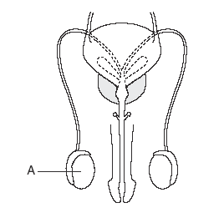
- The diagram below represents the reproductive system of a mammal.
The hormone produced in structure A most directly brings about a change
(1) in blood sugar concentration
(2) in physical characteristics
(3) in the rate of digestion
(4) in the ability to carry out respiration

- Why does the lining of the uterus thicken during the first half of the menstrual cycle?
(1) to provide a place for sperm cells to attach
(2) to produce a mature egg cell
(3) to prepare to nurture an embryo
(4) to rid the body of unfertilized egg cells

- Which of the following occurs earliest in the menstrual cycle?
- The ovaries release a mature egg into the fallopian tubes
- Progesterone levels rise, thickening the uterine lining
- The uterine lining breaks down and is shed through the vagina
- Estrogen levels rise, thickening the uterine lining

- Use the data below to answer questions A, B and C. The data in the table below indicates the presence of a specific reproductive hormone in blood samples taken from three individuals. An “X” in the hormone column indicates a positive lab test for the appropriate levels necessary for normal reproductive functioning in that individual.
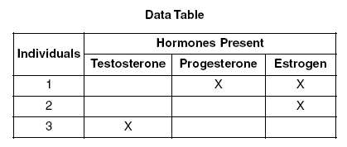
(a) Which processes could occur in individual 3?
(1) production of sperm, only
(2) production of eggs, menstruation
(3) production of sperm and production of eggs
(4) production of eggs, only

(b) Which of the following is most likely true for individual 1 but not individuals 2 or 3?
(1) Thyroid hormone levels are low (3) the individual is menstruating
(2) Production of sperm has decreased (4) the individual is pregnant

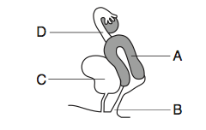
Use the diagram below to answer questions 6. The letters in the diagram below represent structures in a human female.
6. Estrogen and progesterone increase the chance for successful fetal development by regulating activities within structure
(1) A (2) B (3) C (4) D

7. Hormones produced by the testes control the expression of traits for
- hair color and eye color
- beard development and number of fingers
- hair color and voice quality
- voice quality and beard development

REVIEW QUESTIONS
8. When examining a sample of Hydra (a small, coral-like marine animal), a scientist observed what appeared to be a small piece of the hydra break off and settle next to it. Over the next several days, the “piece” appeared to grow into a new hydra. Briefly identify the process the scientist observed, and provide an additional example of this process.
____________________________________________________________________________________________________________________________________________________________________________________________________

9. Compare and contrast asexual and sexual reproduction.
_______________________________________________________________________________________________________________________________________________________________________________________________________________________________________________________________________________________________________________________________________________________________________________________________________

