Living Environment
Unit 7 Evolution: Do only the strongest survive?

Name: ________________________________________________ Period: ____ Date:

Homework 36: Phylogenetic Trees
AIM: How can we visually observe the evolutionary relationship between organisms?

Directions: Answer the questions below to the best of your abilities using your knowledge of biology.
The evolutionary pathways of ten different species are represented in the accompanying diagram.
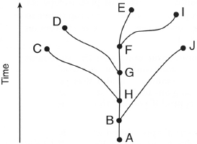
1. Which two species are the most closely related?
(1) C and D
(2) E and I
(3) G and J
(4) A and F

Use the diagram below to answer question 2. The diagram below shows the evolution of some different species of flowers.
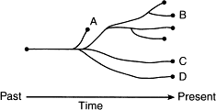
2. Which statement about the species is correct?
(1) Species A, B, C, and D came from different ancestors.
(2) Species C evolved from species B.
(3) Species A, B, and C can interbreed successfully.
(4) Species A became extinct.

3. The diagram below represents possible evolutionary relationships between groups of organisms.
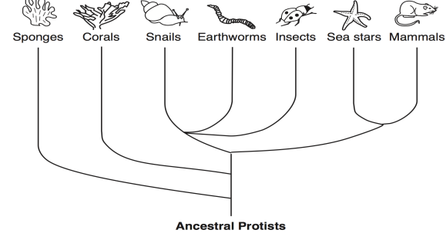
Which statement is a valid conclusion that can be drawn from the diagram?
(1) Snails appeared on Earth before corals
(2) Sponges were the last new species to appear on Earth
(3) Earthworms and sea stars have a common ancestor
(4) Insects are more complex than mammals

4. Which statement best explains the patterns seen in these diagrams?

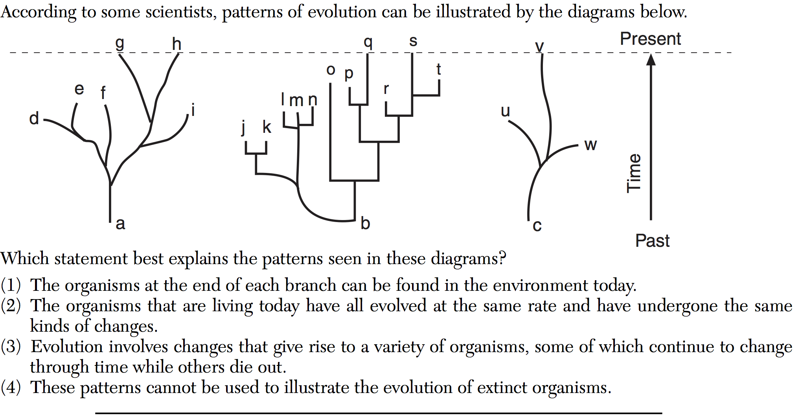
(1) The organisms at the end of each branch can be found in the environment today

(2) The organisms that are living today have all evolved at the same rate and have undergone the same kinds of changes

(3) Evolution involves changes that give rise to a variety of organisms, some of which continue to change through time while others die out

(4) These patterns cannot be used to illustrate the evolution of extinct organisms

Use the diagram below to answer question 5. The accompanying diagram illustrates a proposed evolutionary path of certain organisms, based on the theory of evolution.
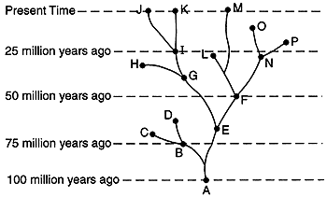
5. Which statement could best be inferred from the information in this diagram?
(1) Evolution does not involve gradual change
(2) Evolutionary changes can result in extinction
(3) Evolution begins with plants
(4) Evolution produces organisms that all fill the same niche

Use the information below to answer questions 6 and 7.
A scientist working on an island near the Galapagos discovers a new species of marine iguana. She sequences a protein molecule found in its blood and compares it to the sequences of similar protein molecules in 4 known species of iguanas found on other islands. Her results are presented in the chart below:
IGUANA SPECIES | PROTEIN SEQUENCE
Newly Discovered Species | Trp – Trp – Pro – Leu – His – His – Pro – Val - Ala
Green Iguana | Trp – Trp – Pro – Tyr – His – Pro – Pro – Val - Val
Antillean Iguana | Pro – Trp – Pro – Leu – His – His – Pro – Val - Val
Cayman Iguana | Trp – Pro – Ile – Leu – His – His – Pro – Pro - Pro
West Indian Rock Iguana | Val – Trp – Pro – Leu – His – His – Pro – Val - Ala
6. Which species is the newly-discovered Iguana most closely related to? Support your answer.
__________________________________________________________________________________________
__________________________________________________________________________________________

7 . Based on the information in the data table, write the names of the organisms from the table in their correct positions on the evolutionary tree below. 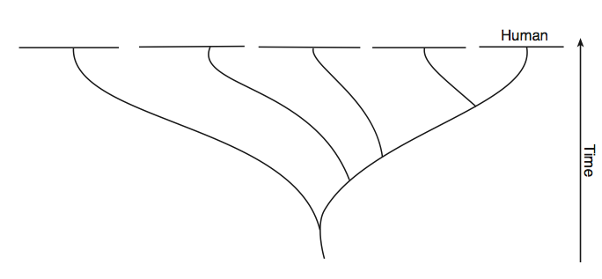
Newly Discovered
Iguana Species

