Name: _____________________________________________ Per: ______ Date: ________
Simulating the Transmission of Disease

Background: The rapid spread of a disease is known as an epidemic and is of great concern to public health officials, who must learn how a disease is transmitted and then attempt to control it. Epidemiologists are scientists who study the cause and spread of diseases through populations. By doing this, they can help prevent or control the spread of diseases.
AIDS is a condition caused by the Human Immunodeficiency Virus or HIV. HIV can be contracted through an exchange of contaminated body fluids (blood, semen, needles). Hepatitis strands A, B, and C are also spread through fluids; according to the CDC, the Hepatitis B virus can survive up to 7 days outside the body and still cause infection! Syphilis is caused by a bacterium and is spread through direct contact with a sore during sexual activity or from mother to child.
HIV/AIDS, hepatitis, and syphilis are all deadly pathogens. Many other types of pathogens, though not deadly, cause health complications and financial stress. Governmental reports show in 2007, 46,277 cases of HIV/AIDS reported, 8,347 cases in 2007 of hepatitis, and in 2008, 46,277 cases of syphilis. These individuals actually tested positive for infection in a lab.
In today’s world, it is important for people and doctors to keep track of sexual partners and other dangerous activities to attempt to stop the spread of dangerous diseases.

Objective: This lab is to understand the transmission of disease caused by certain bacteria and viruses and analyze how quickly individuals in a population can become infected. During this lab, you will use a chemically contaminated liquid to observe how quickly a pathogen (disease causing agent) spreads in a population.

Problem: How quickly can a disease be spread between people?

Hypothesis: In our class, let’s imagine that one of our classmates is “infected” with a disease. If our class exchanges fluids representing the disease, how quickly will the “disease” spread? Write a hypothesis predicting how many people will be infected by the end of the class period.
“If one person is infected, after the exchange, then…”
________________________________________________________________________________________________________________________________________________________________________________

Procedure:
- Everyone choose a beaker from the table.
- Most of these solutions are neutral, representing healthy persons in the population. One unknown person in the class will be given a contaminated solution, representing an infected person in the population.

- When your teacher gives the signal, begin round one of the transfers. Choose a classmate at random for the exchange. Exchange fluid by pouring half of your solution into theirs and then vice-versa (reversed).
- Record the names of the classmates you exchanged fluid with in Table 1. You may only exchange fluids with a person once. You must exchange fluids every round

Table 1: Personal Data
Round | Persons Contacted | Contamination Test  (+ change, - no change)
1
2
3
4
5
6
7
8

- When your teacher gives you the signal, carry out a second round of transfers, with a different classmate. Record the name of the 2nd classmate you exchanged fluid with in Table 1.
- After every EVEN round, test your fluid for contamination. Obtain the indicator solution from the teacher and watch for a reaction in your solution. A color change indicates infection.
- Repeat steps 1-6 until table one is completed.
- Record the names of students infected after each round in Table 2. Use this information to deduce who was the first person infected
Table 2: Class Data
Round | Persons infected | Number of people infected
2
4
6
8

Infection Analysis: Who do you think was the “first infected” person in our class? Why? Back up your opinion with evidence from your data table.
________________________________________________________________________________
________________________________________________________________________________
Further Analysis:
Table 3:
Total # Infected
/Starting Pop
X 100 = | %
- How many students were in the class at the beginning of the activity? _____
How many students were “infected” by the end of the activity? _____

- Calculate the percentage of people who became infected (Table 3). Create a circle graph representing the percentage infected after our activity.

- What percentage of classmates ended up infected versus uninfected? Explain how one carrier can infect so many people in the population?

- What are four methods of transmission discussed in the introduction?
  - ________________________________________________
  - ________________________________________________
  - ________________________________________________
  - ________________________________________________

- Graph the number of interactions vs. number of people infected in a line graph below. (Title, X axis, Y axis, even scale, correctly plotted points)

- What do you guys notice as the number of interactions increase? Why do you think the number of infected also grows?

- What type of relationship does the graph show between the two variables?

- HIV/AIDS, hepatitis, and syphilis are caused by viruses and a bacterium. What is the difference between a bacterium and a virus? Fill in the Venn diagram below with at least one item for each section. (2 pts)

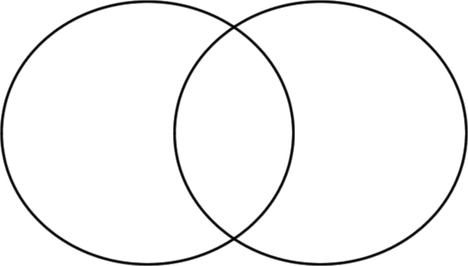

- As of now, there is no HIV Vaccine. But there are vaccines for other bacterial and viral infections. What is a vaccine, and how does it work?

- Review ways that individuals can protect themselves from ALL types of disease (HIV/AIDS, flu, chickenpox, etc.)? List at least three ways to stay safe.
- _____________________
- _____________________
- _____________________

Conclusions: Read and answer the problem for this laboratory investigation. How quickly can a disease spread between people? How did the laboratory activity demonstrate this concept? Was your hypothesis correct or incorrect? Use specific examples from the lab. In what way(s) is our lab different in reference to the means of transmission (fluid)? Can other diseases be spread in different ways? Write your answer in complete sentences.
LAB COMPONENT | PTS | RECEIVED
Participation | 10
Hypothesis | 2
Table 1 | 5
Table 2 | 5
Infection Analysis | 2
Further Analysis | 9
Conclusion | 6
Total | 39

