Living Environment Lab Safety Rules Quiz
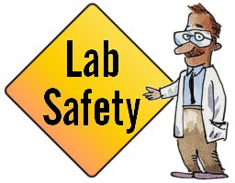
- True / False : When first entering the classroom do not touch any of the equipment
- True / False : You may complete experiments that haven’t been approved by teacher
- True / False : If you do not understand a direction or part of a procedure or how to use equipment, ask your teacher before proceeding.
- True / False : You can eat in the classroom as long as you are not at your lab table.
- Why is it important that you never fool around in the laboratory?
______________________________________________________________________________________________________________________________________________________________________________

- True / False: If you see unsafe conditions, take care of it yourself
- True / False: If you spill a chemical on your hands, you should use the laboratory shower
- What are three things you cannot wear in lab?
  - ___________________________________
  - ___________________________________
  - ___________________________________
- True / False: If there is an emergency or injury, call 911 first.
- True / False It is safe to smell and taste unknown chemicals or substance
- Why don’t you ever return unused chemicals to their original container?
- True / False: You are allowed to take home chemicals and equipment out of the classroom if you do not finish the lab in class
- True / False: Always point the mouth of a test tube away from yourself and your lab partners

What is wrong with these pictures? How can they correct their behavior?



